Proposal
Big Ten Student Design Challenge
University of Nebraska-Lincoln | MORPH
[Sheila Cobb, Megan Jespersen, Joshua Frederick, David Huismann]

Vision
The space, located on the second floor of Louise Pound Hall (LPH), is adjacent to several teacher offices and is a mezzanine above a general student use area. The lack of student use areas on the second level present a problem for our team to attract students to this area to be used as an informal learning environment in between classes.
This space is geared towards students that are seeking a quieter space with both individual zones and small group zones. The inspiration for this space comes from furniture from Herman Miller collection including the Soft Square and the Polly chair. The Soft Square is a soft seating piece that can be used for both individual and group work, it is a moveable piece, and gives the students more control over their space. The colors chosen for the elements in the space give an opportunity for branding for the University of Nebraska.

Description
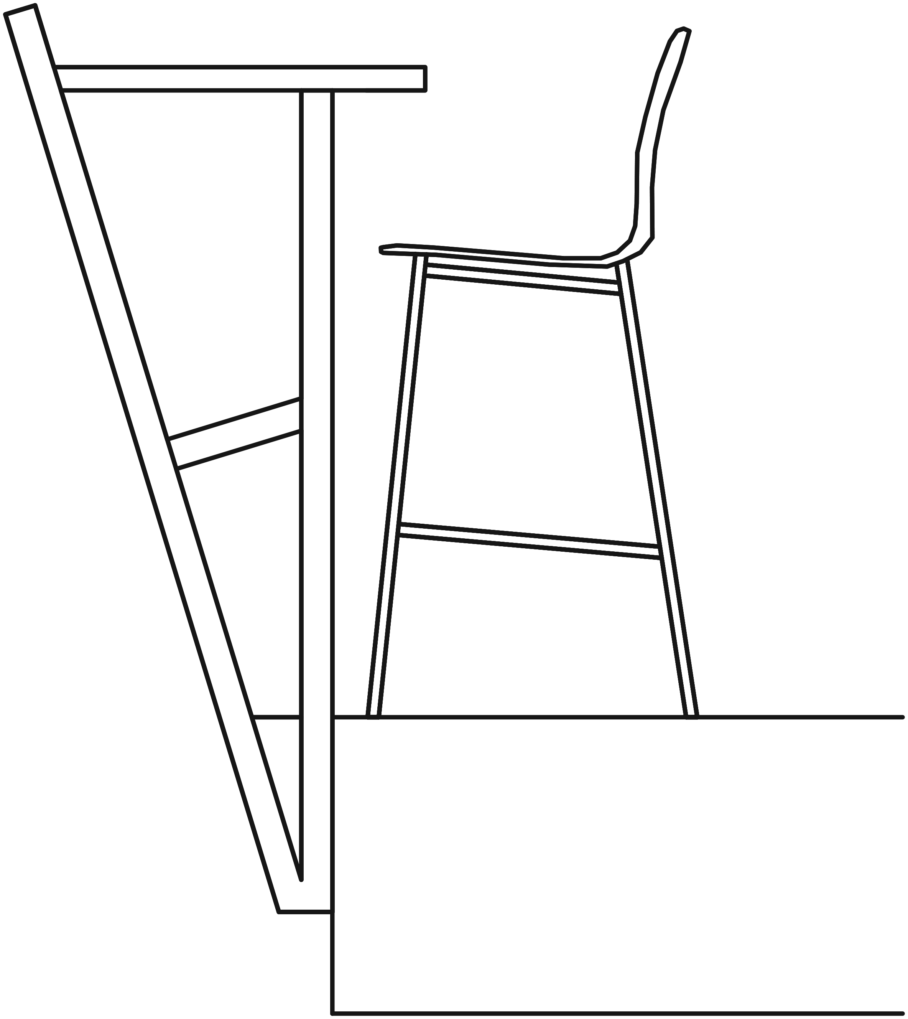
The Polly Chair is used along with the Everywhere table along the railing. The railing will be changed to accommodate the bar seating. Inspired by the Polly Chair, the table top will suspend at bar top height over the railing. This railing will provide a place for feet to rest, power to come through, and frosted glass in the front to give more privacy from below. They are placed towards the windows and away from the hallway and classroom to offer a less obstructed and more permanent area for the students. The Everywhere table will be cut to fit along the railing suspending 1’6” over the mezzanine and only 6” into the space to allow for more walking and working space. This table can be used in any type of environment and can be customized to fit in a limited area like this space.
Another furniture choice is the Knot table. This table is great for this space because it works as the perfect scale to go along with the Soft Square and the Always chair. The light weight table allows for students to create their own space and move pieces as they need. The Always chair is also being used to provide more comfort and a more relaxing environment. This chair can be used for both short and long periods of time, therefore we placed them close to the high traffic area as well as closer to the windows to offer a small lounge.
Marker boards will also be used on the walls so that students can utilize the wall space as their own study area. Privacy panels will be customized to become acoustical panels along the walls. Similar to the wall acoustic panels, the hanging ceiling panels will be the privacy panels repurposed into boxes and hung from the ceiling. Some will be enclosed boxes, others provide the opportunity to transform into a light fixture. As you look down the hall way or directly at the space, students can see these panels spell out N for Nebraska which will attract them to the space and provide a branding moment. As they walk around, the ceiling panels are broken up and look sporadically placed following the solid movement through the space. This design provides space for students to gather around the mezzanine as well as creating an acoustically sound environment.
With the $15,000 university budget, carpet will be used to create zones and attract students into the space. The square tiles were inspired by the Soft Square and will help further develop our concept. The carpet provides the continuation and the solid movement through the space. The railing around the mezzanine will be changed to accommodate the bar seating.

Itemized Expenses
from Herman Miller Custom Catalog
Item (include link and unit price) | Quantity | Cost
Polly Bar Stool $590 | 14 | $7,080
Always Chair $1,622 | 8 | $12,976
Knot Table $785 | 4 | $3,140
Soft square $250.75 | 12 | $3,009
Everywhere table $898 | 4 | $3,592
Acoustic Panels $701 | 20 | $14,020
Marker Board $61 | 2 | $122
Total (Maximum $80,000) | - | [$43,939]

