PROPOSAL
Big Ten Student Design Challenge
University of Illinois at Urbana-Champaign | Superstudio

Estefany Chavez-Ruiz David Figueroa
Harjot Sidhu

VISION

The Foreign Language Building is right off the main quad and one that most students are familiar with through language classes, student organization meetings, and cultural events that take place inside. This building is used around the clock throughout the week by students for reasons ranging from foreign film screenings to gathering for group projects. Our vision is for this space to acknowledge its prime location through furnishings that allow flexibility to accommodate the variety of happenings that the student body participates in this spot. We plan to pursue this through multifunctional furniture that students can move themselves. Tables and chairs and vital for productive work flow, couches and coffee tables for socializing and decompressing —both weekday and weekend attributes.
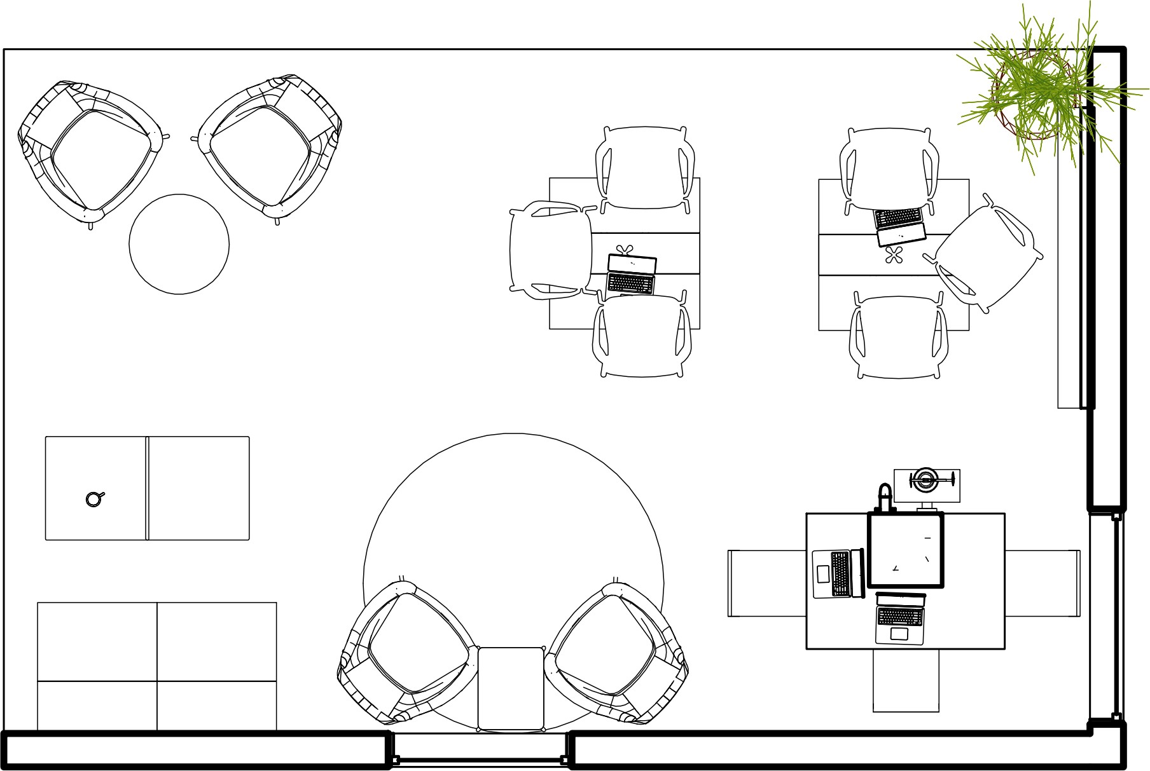

DESCRIPTION

Our vision for this space is very fluid and adaptable to the varying ways the we see our fellow students shift from work mode to relaxation. Through this observation, we wanted to bring pieces that reflect this lifestyle. We incorporated the Swoop Armless Chair with elements like the Keyn Chair to bring harmony to the space and provide furnishings that act as the perfect platform for students to go about settling in or stopping by for a quick sit. We’ll walk through the floor plan from left to right — from lounge to study. On the left as you enter this corner spot, you’ll see the Swoop Armless Chair in an orange hue paired with wooden Swoop Box Tables to define this area as a place to kick back with a computer on your lap and an iced coffee on the table or catch up with a friend in between classes. Across from the Swoop Pairing are two Always Lounge Chairs along with a blue Drum Pouf. The Always Lounge Chairs are placed at the most visible corner since they look great from every angle, adding to the aesthetics of the space. The slim and light legs of the Always Lounge chairs bring an airy feel to the area and invites students to take a seat in this elegantly simple chair. Placing a Drum Pouf between the Always Lounge Chairs brings a more relaxed ambiance to this corner, designating it as the ultimate chill section of this spot. Moving towards the middle we wanted to keep this space open since it would allow student flow and flexibility for the furniture to move as well. The Always Lounge Chair is repeated here but paired with a Circular Knot Table. This provides a subtle nudge towards productivity with the Knot Table providing a platform for a quick snack and laptop to sit on. The Knot Table is one of our favorites, having an elegant and functional top with a playful and vibrant bottom. Once we reach the right end of our space, it is work time. The Square Foldaway Tables fit with our multifunctional vision. They can be left open with Keyn Chairs presenting a full platform to have group study sessions varying from 2-6 people.
This area also will include a Glass White Board for a sleek way to work out problems in a group and display any current events or happenings in the building since it can be viewed by those in the space as well as by anyone passing by. For events that call for more open space, the Keyn Chairs can be staked and stored in a corner and the Square Foldaway Tables can be efficiently set aside. Overall, this space can comfortably fit 15 students and cater to their needs whether its finding a study spot, waiting while friends are in class, or lounging around.

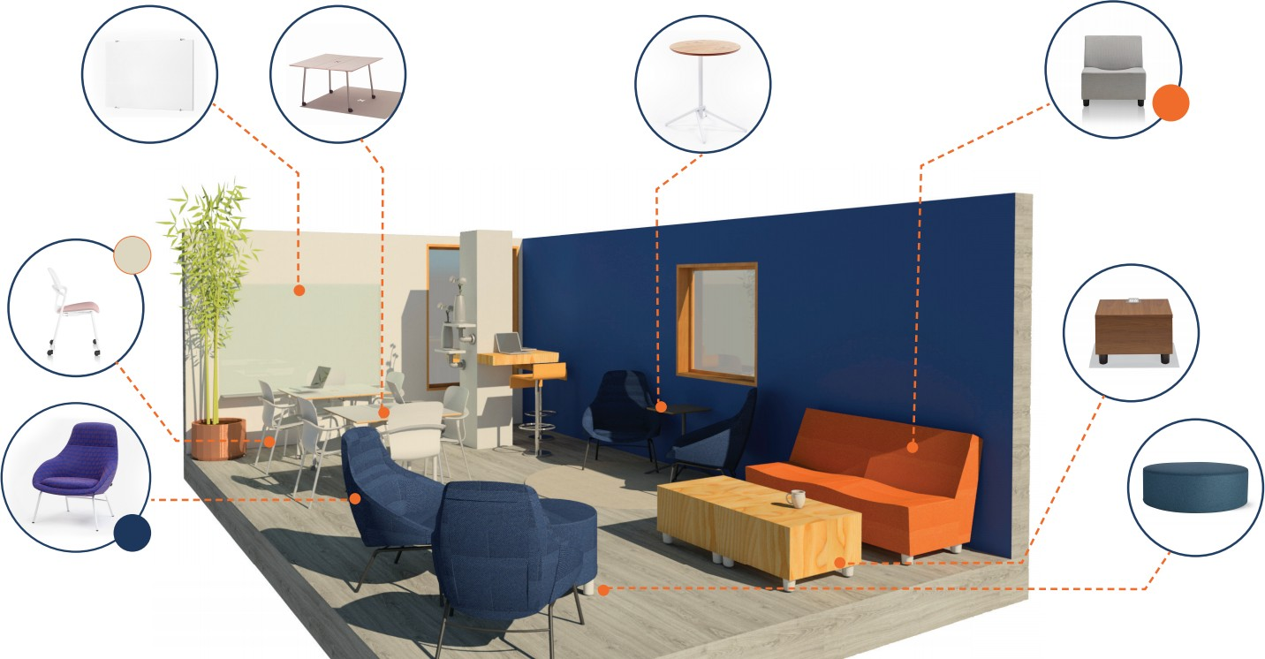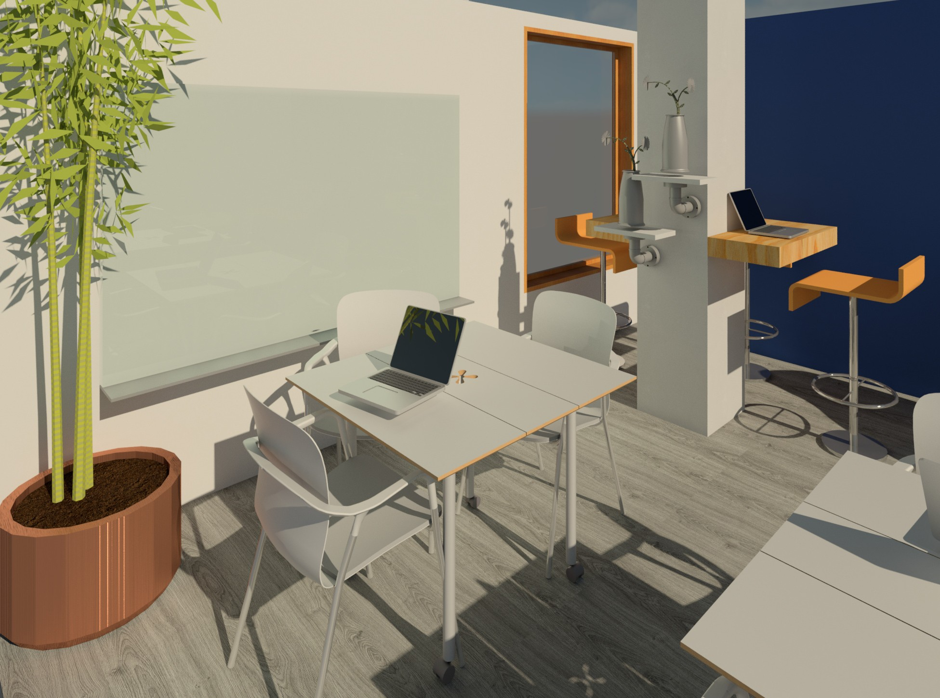Being that our space is in the basement, we’d like to bring life into this spot through plants. Keeping the table surfaces clear for students to use, we will utilize the walls and hanging spaces to suspend air plants and succulents.
These plants also help improve the indoor air quality and connect the outdoors to this basement spot.
Keeping with the worldly activities and events that take place in the building, we wanted to showcase the diverse student body that comes through this
spot by having an interactive push-pin world map. It offers both a dynamic element to the space allowing students to display their representation and as a sophisticated piece of ever-evolving wall art. In the middle of our space, we decided to keep it open and offer a change in flooring by adding a round rug. This offers variety and a cozier feel to the center open space. There is also a column that interrupts the space that we have decided to utilize as a bar table area. Adding an elevated wooden table around the column and bar stools lightens up this area while also upping its usability.

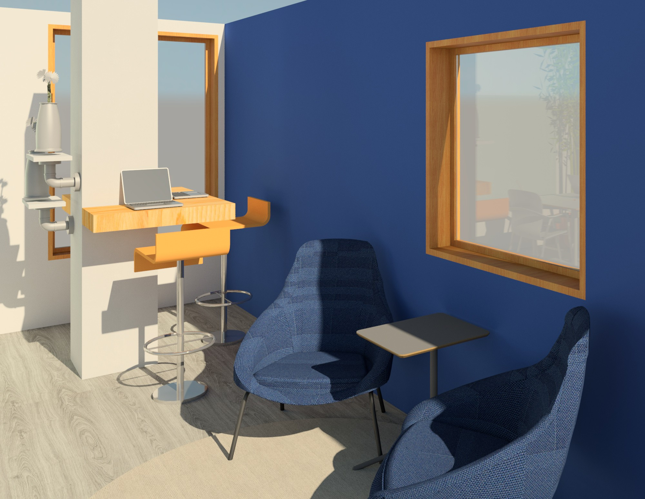

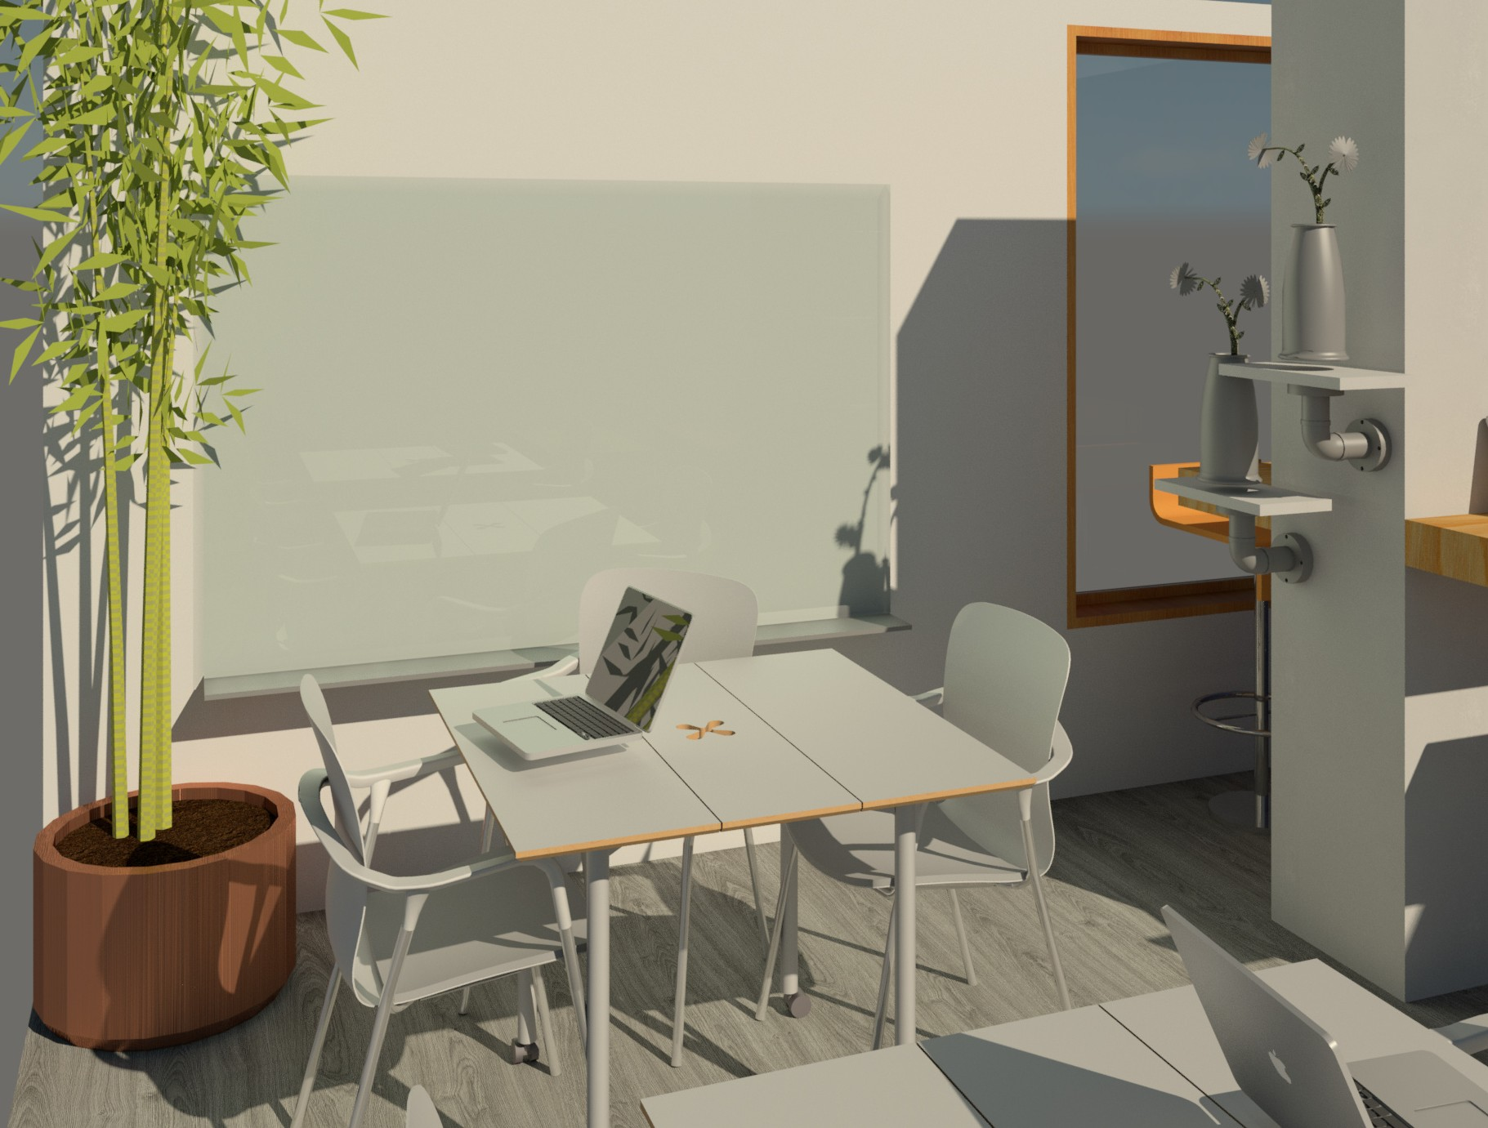
For our flooring we decided to go with a silver umber gray oak laminate. It is categorized as an AC5 rated flooring, making it a great choice for public buildings and areas of heavy traffic like our space. This color and finishing complements the furnishings that we have chosen while still letting the furniture have prime spotlight. This flooring allows for the furnishings to cleanly move and elevates the flexibility of the space.
The walls will be simple with white and navy blue to act as the canvas for our choice of wall accessories. There is also a non-structural CMU partition wall that boxes off the space. We plan to remove this partition to open up the space and have less of a literal wall that impedes flow.

ITEMIZED EXPENSES

FROM HERMAN MILLER CUSTOM CATALOG

ITEM (INCLUDE LINK AND UNIT PRICE) | QUANTITY | COST
[Swoop Armless Chair $1856] | 2 | [3,712]
[Swoop Box Table $1065] | 2 | [2,130]
[Drum Pouf, Cocktail $595.00] | 1 | [595.00]
[Knot Table, Circular $849] | 1 | [849]
[Always Lounge Chair, $2,578] | 4 | [10,315]
[Glass White Board, $4,650] | 1 | [4,650]
[Square Foldaway Table, $2,170.5] | 2 | [4,341]
[Keyn Chair,$667] | 6 | [4,836]
Total (Maximum $80,000) | 19 | [ 31,428]
ADDITIONAL ELEMENTS

ITEM | QUANTITY | COST
[World Travel Map with Pins, $129,99] | [1] | [$129,99]
[Wall Geometric Hanging White/Gold, $12.99] | [4] | [$51.96]
[Watermark Round Rug, $349] | [1] | [$349]
[Case Study Planters with Walnut Stand, $149.00] | [1] | [$149.00]
[Claudine Adjustable Height Swivel Bar Stool, $181.98] | [3] | [$545.94]
Total (Maximum $5,000) | [9] | [$1225.89]

