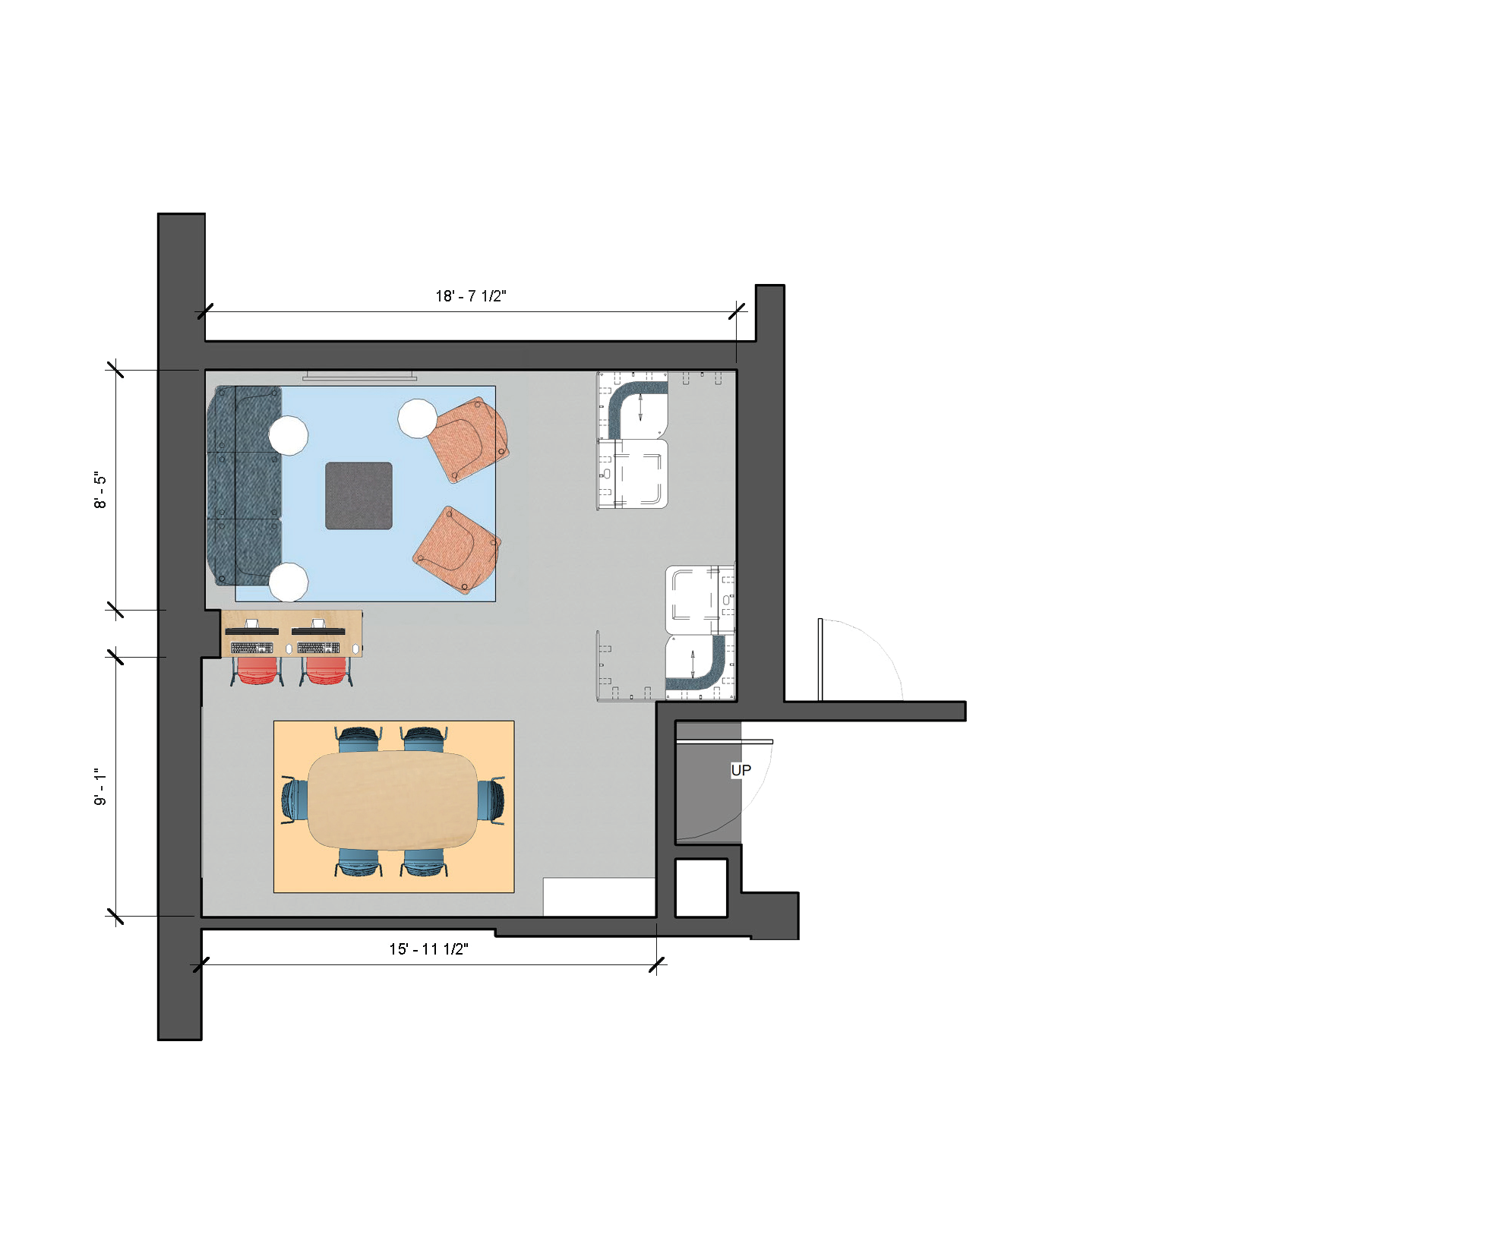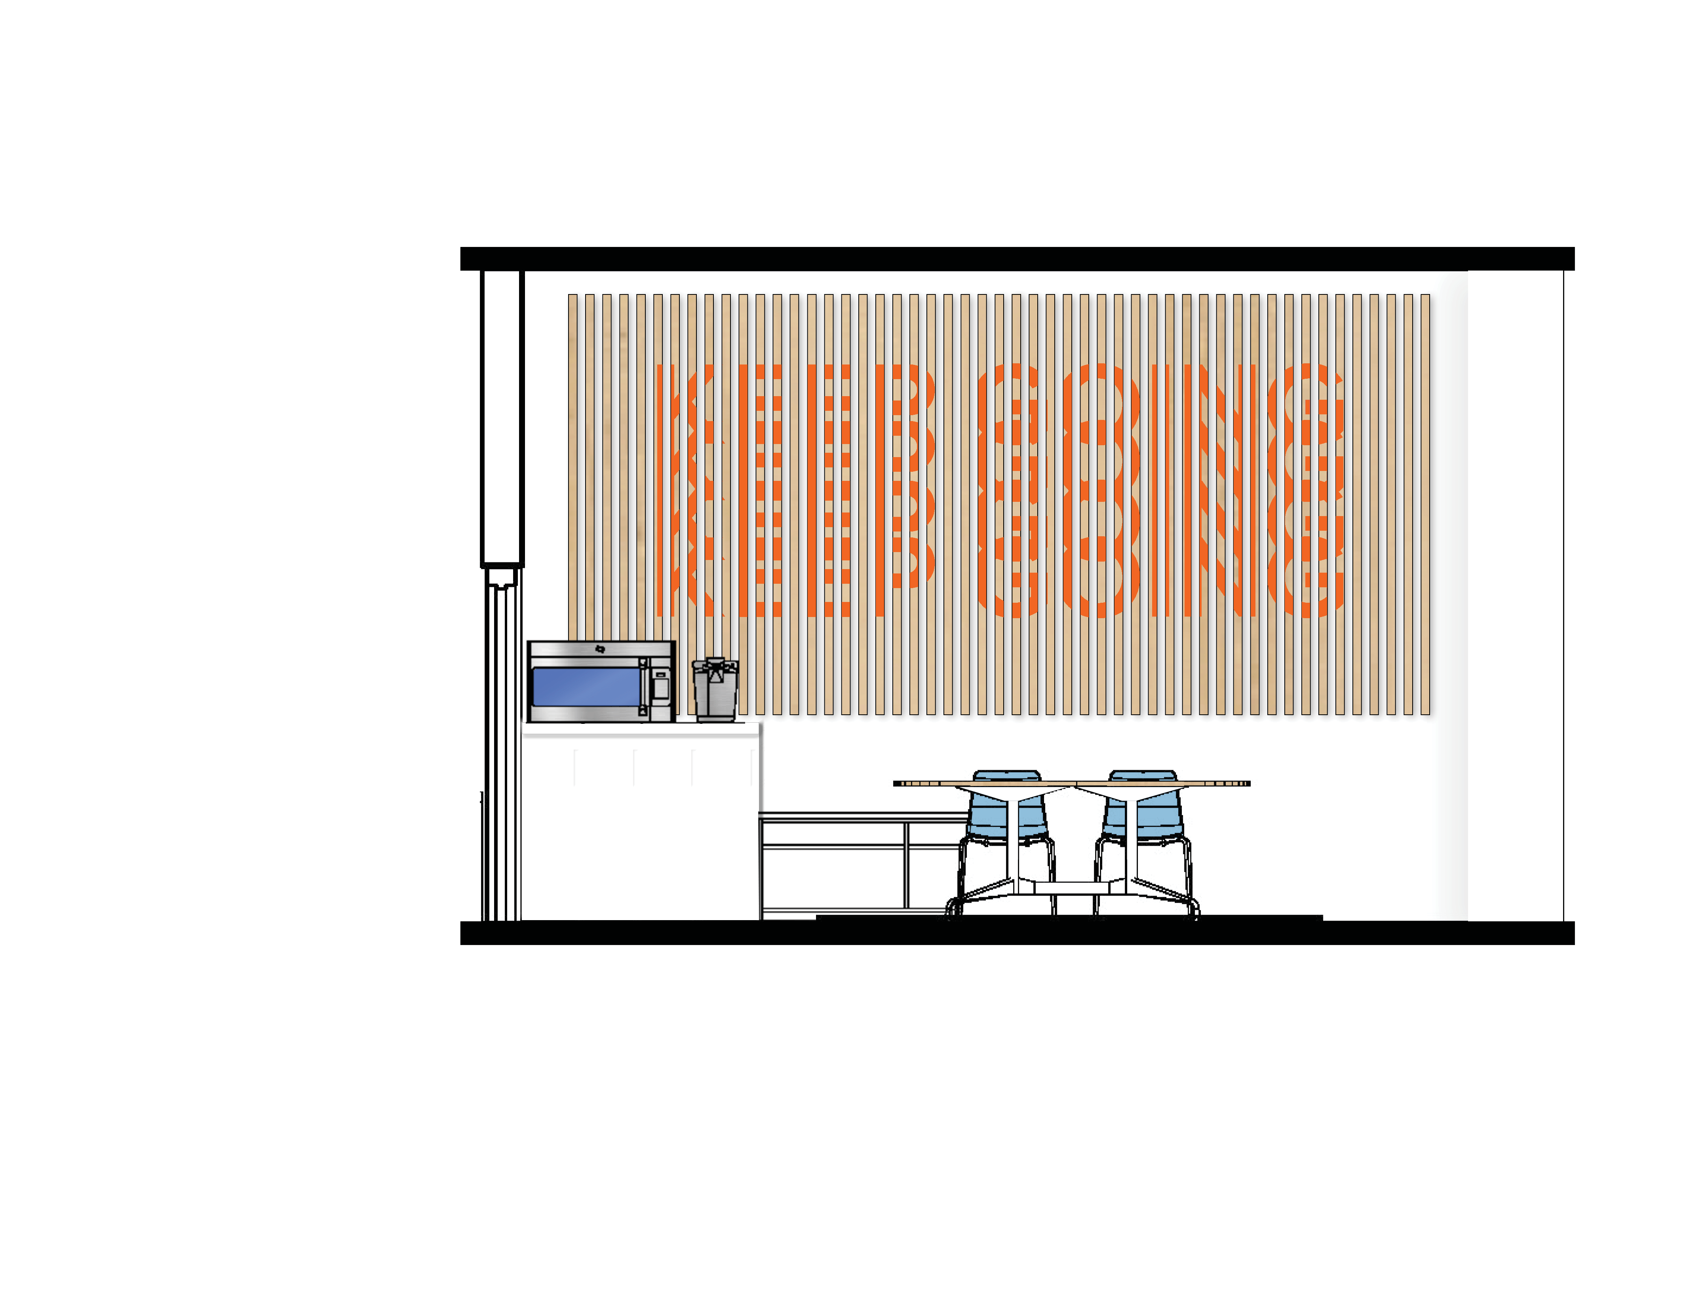
PROPOSAL
Big Ten Student Design Challenge The Ohio State University | 3 Bucks [Tyler Hatton, Haemin Park, Kelia Todd]

VISION

Our vision of the space is to create a student focused, stress-free environment. We want this third space to be dedicated to students who are looking for a place to relax and debrief, as well as provide a common space where students and staff can meet up for group tasks. The building our space occupies is used heavily by a wide variety of students in diverse fields, so it is intended to be useful for all students. To create a more comfortable and residential feel, additional lighting mixed with bright but soft colors are used to bring airiness to the room and to evoke uplifting but relaxing emotions. The furniture chosen, along with its placement, creates a landscape of different zones, like an urban, studio loft, with areas for collaboration, relaxation, and concentration.

DESCRIPTION

The selection and arrangement of our furnishings are inspired by urban and industrial studio apartments. Many of these types of spaces can be small, and often have open floorplans.
Thoughtful positioning of chosen pieces can help differentiate areas for certain activities and make the residence more comfortable and functional. Our design uses this rational to create different zones (Collaboration, Relaxation, and Concentration) to meet the varying needs of a diverse student population. Additional elements along with floor and wall treatments emphasize our concept and design strategy.

- Collaboration
An Oval Conference Table from the Eames Collection, surrounded by bright blue Polly Chairs, create the collaboration space. These selections are clean and simple in design, and the bright modern colors invite passerby from hall way traffic to come in. Storage from the Tu Storage Collection is added to increate functionality of the space. The lockers, which can be used as a cubby, are intentionally at countertop height to create a mini kitchenette and are located next to an open credenza with a cushion top for additional seating and storage while creating visual interest. A surface mounted, magnetic glass white board is located behind the conference table to encourage collaboration and exploration. Adjacent to this, the Layout Studio Bar Height table is positioned to provide varying elevations of workspace and to help divide areas throughout the space. Bar height Polly Chairs in a bright orange are used to complement the conference table.

- Relaxation
The Plex Lounge Collection is used to create an area of relaxation. A couch made of the armless seat and left and right armed seats sits across from two single lounge chairs. The addition of the ottoman in the middle creates a surface that can be used as a coffee table or foot rest. These elements create a comfortable, living room environment. The addition of three adjustable work tables provide more surfaces to eat, study, or utilize devices. Power units from the collection are an important feature from this collection, providing a comfortable space for students to charge phones or laptops between classes.

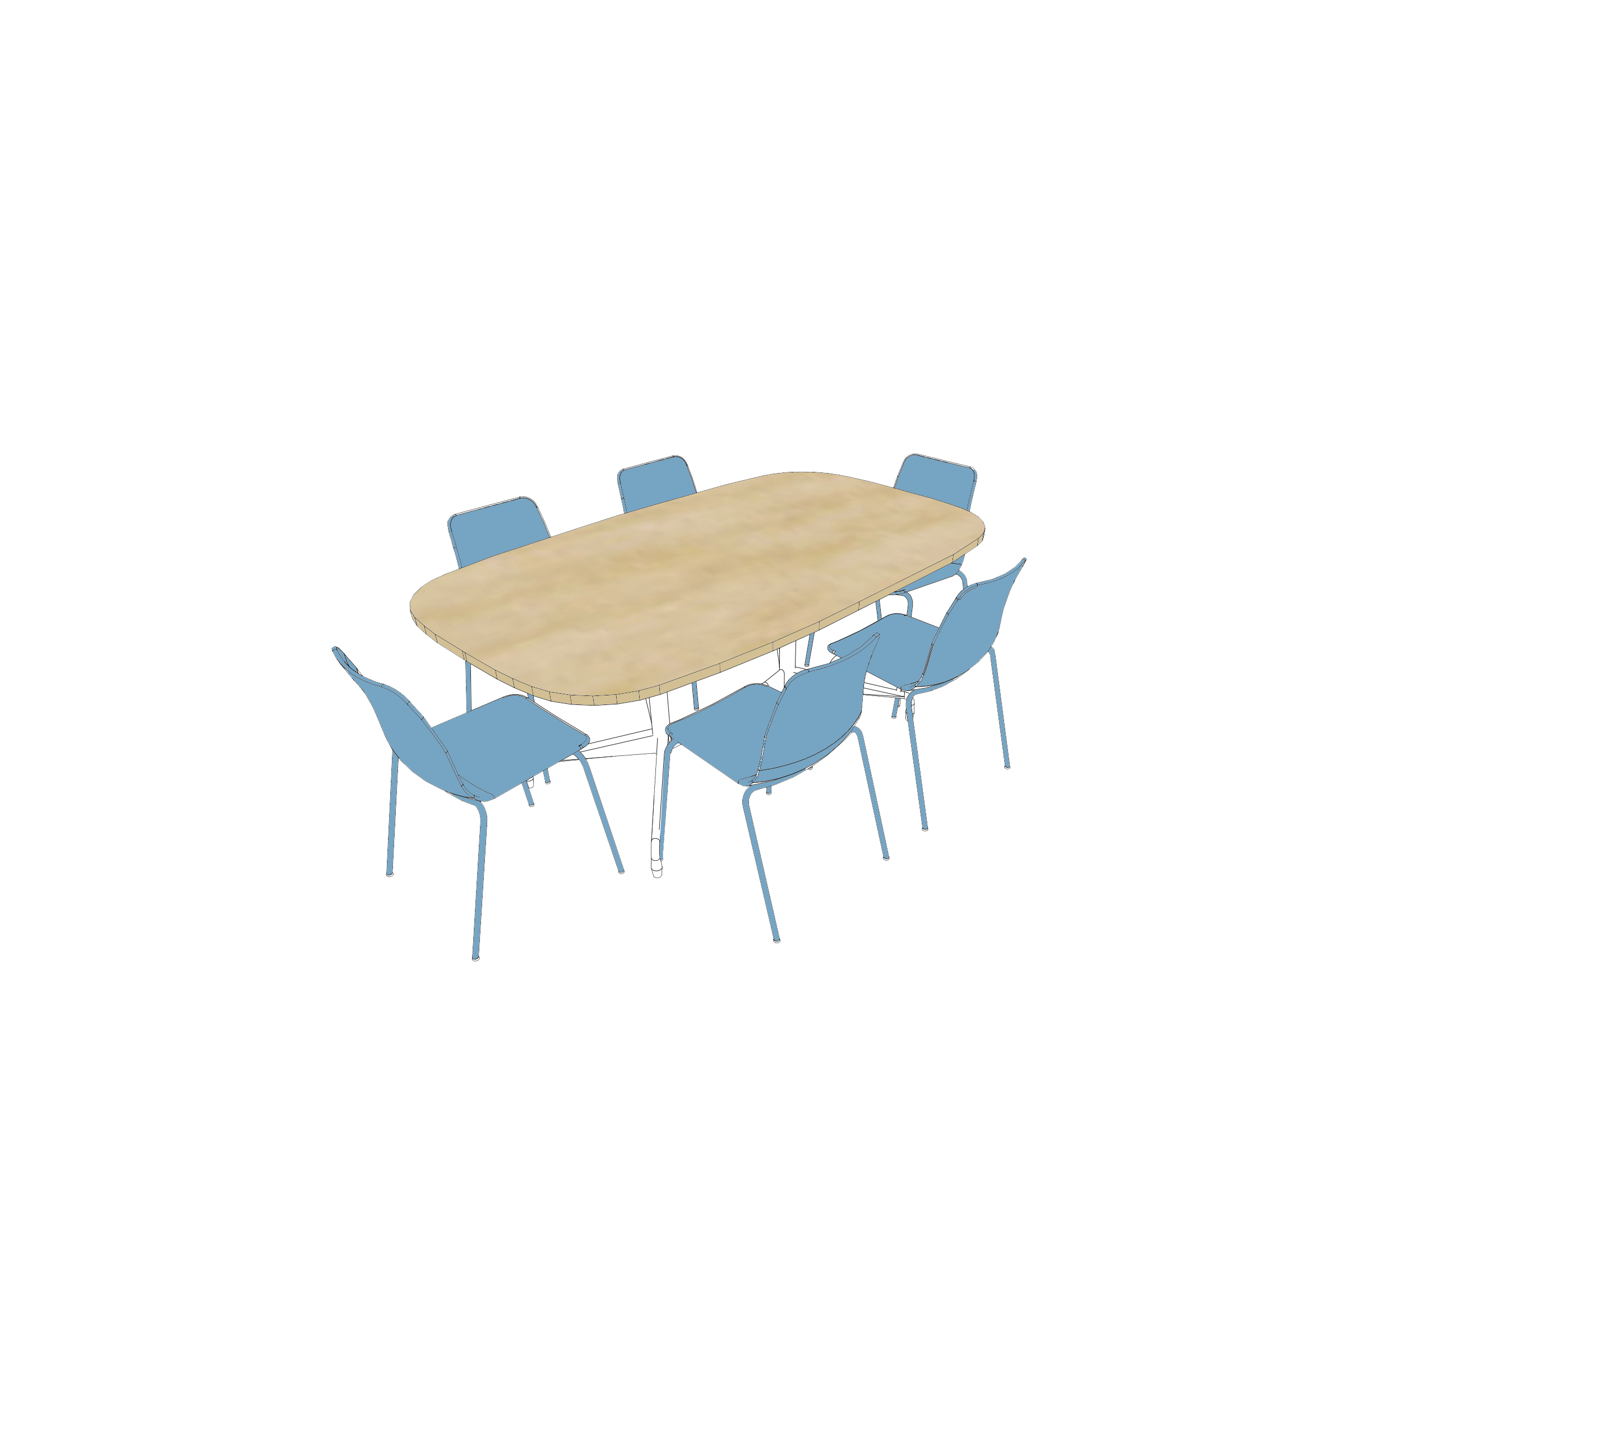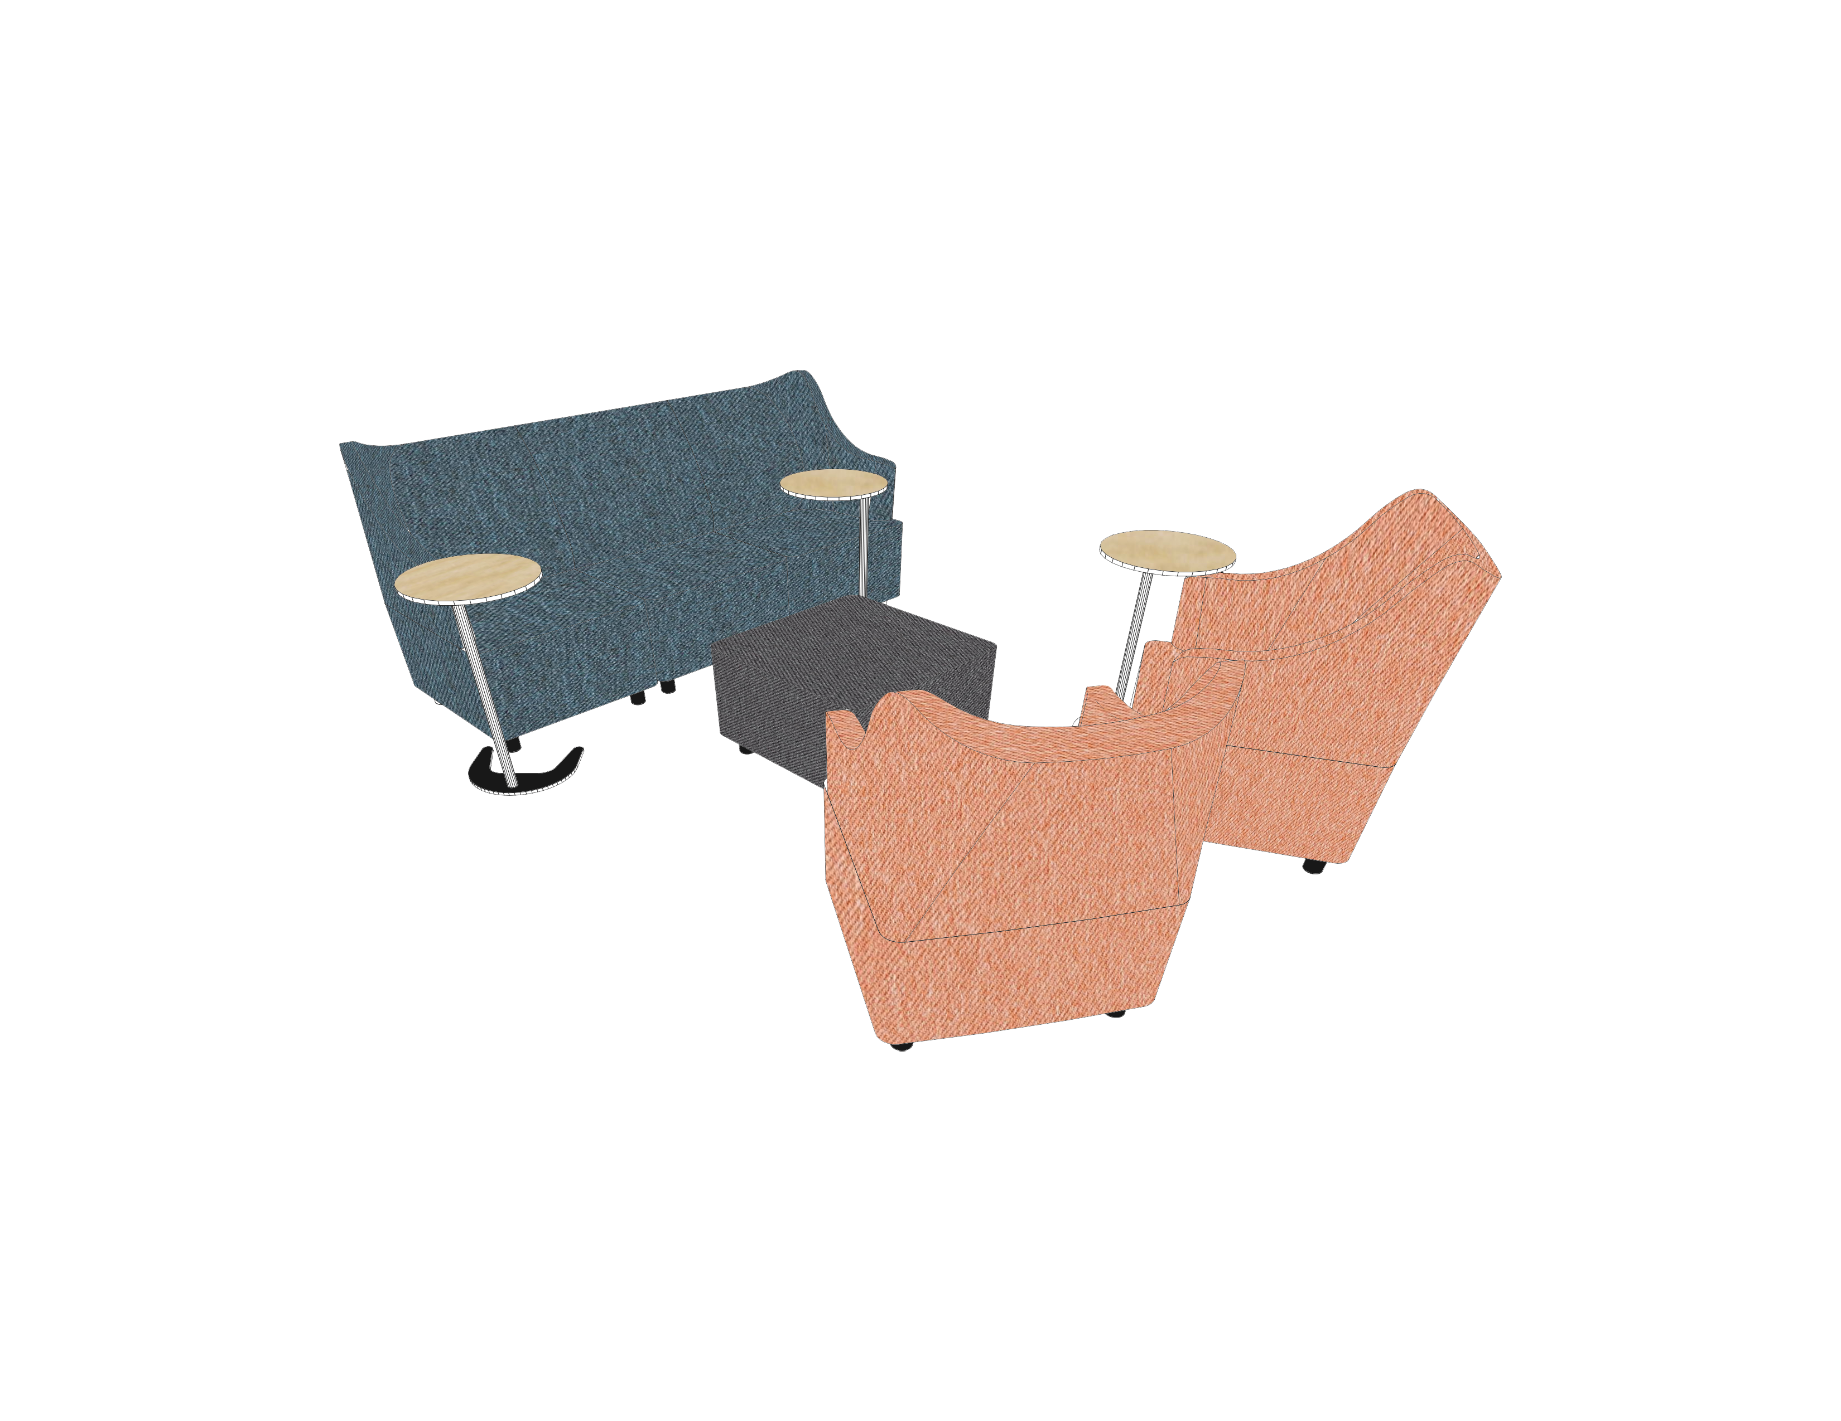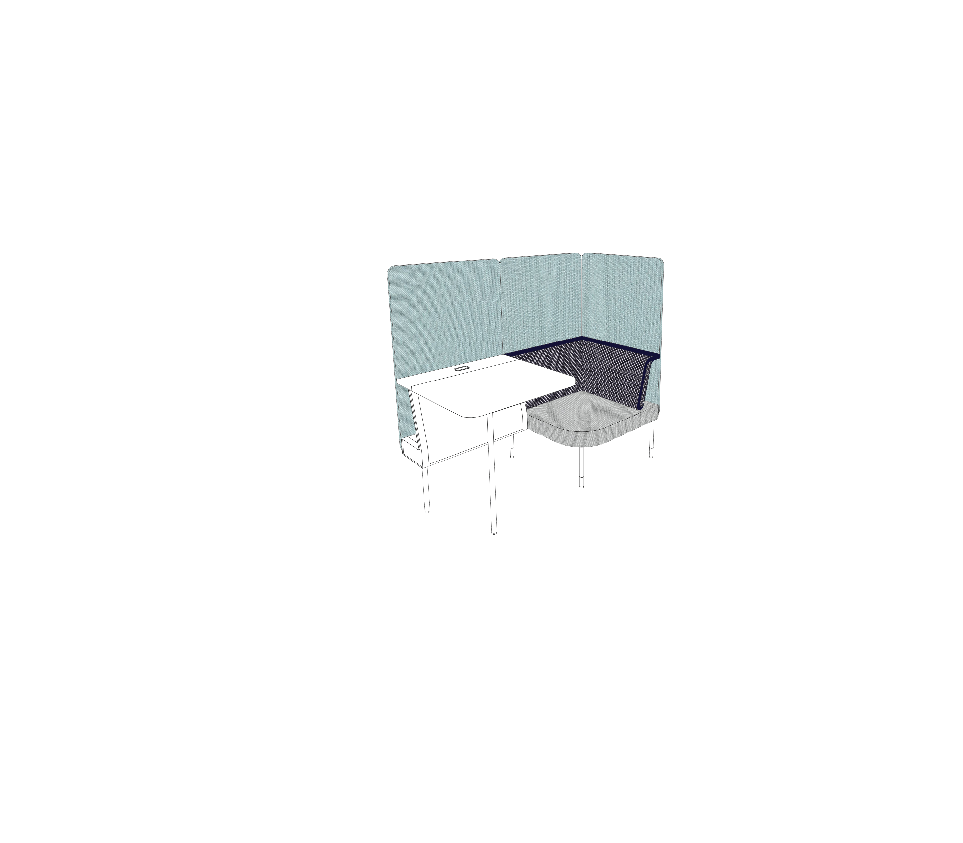3

- Concentration
Using the Public Office Landscape collection, a private area for meditation or focus is created by using screens. The two stations in this area each have a desk and chair (Focus Coffee Table & Social Chair).

Collaboration Relaxation Concentration

- Additional Elements
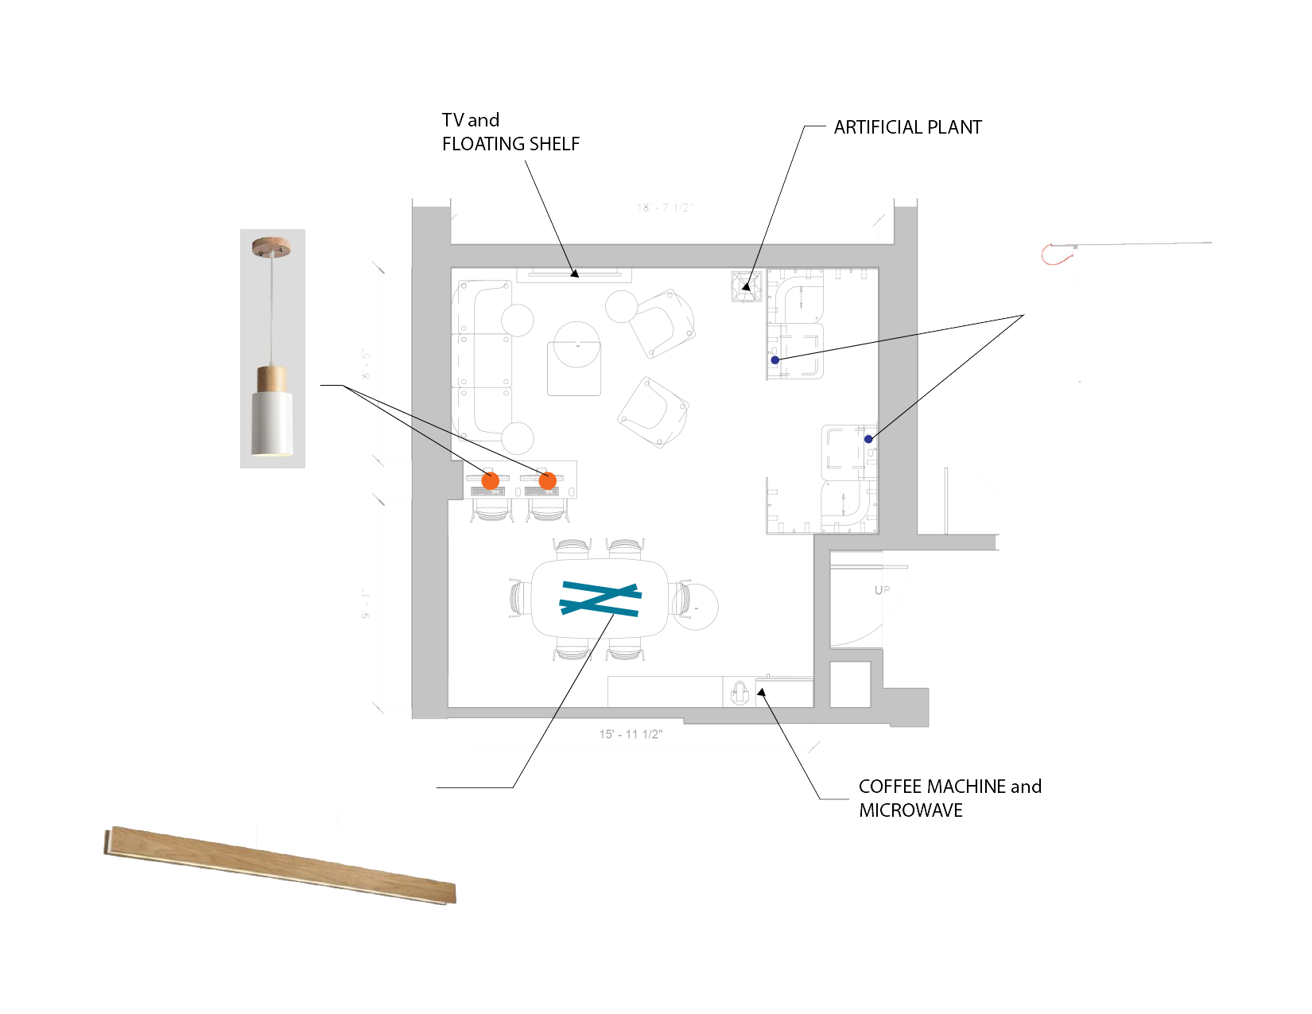The additional elements utilized throughout our space serve two functions. The first, is to emphasize the comfortable and residential feel. The microwave and coffee machine provide convenience to students who need a quick snack or pick me up between classes and is located next to the entrance for students who simply want to use this feature and Keep Going. A wall mounted television and floating shelf provide local and university news and department updates. A faux plant adds to the residential feel and creates vitality. Additional lighting makes working easier on the eye and creates ambience. The second function of the additional elements is to further define the spatial zones. Linear LED lights above the conference table create an eye catching focal point for the zone. Two pendant lights hang over the computer bar and separate the collaboration space from the lounge space. The concentration zone has a table lamp on each desk for personal use.

- Floor & Wall Treatments
The proposed floor and wall treatments further emphasize the urban loft concept and strategy. Dynamic carpet tiles are used throughout in the form of modern patterning and contrasting colors. This creates area ‘rugs’ that define space and complement the furniture selections.
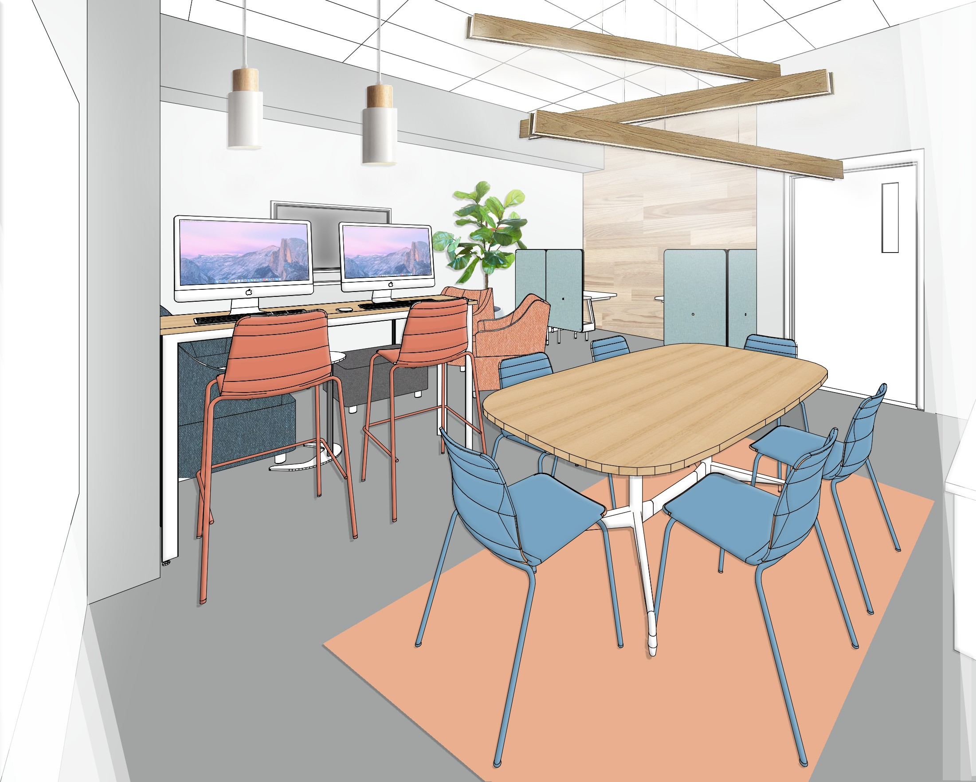
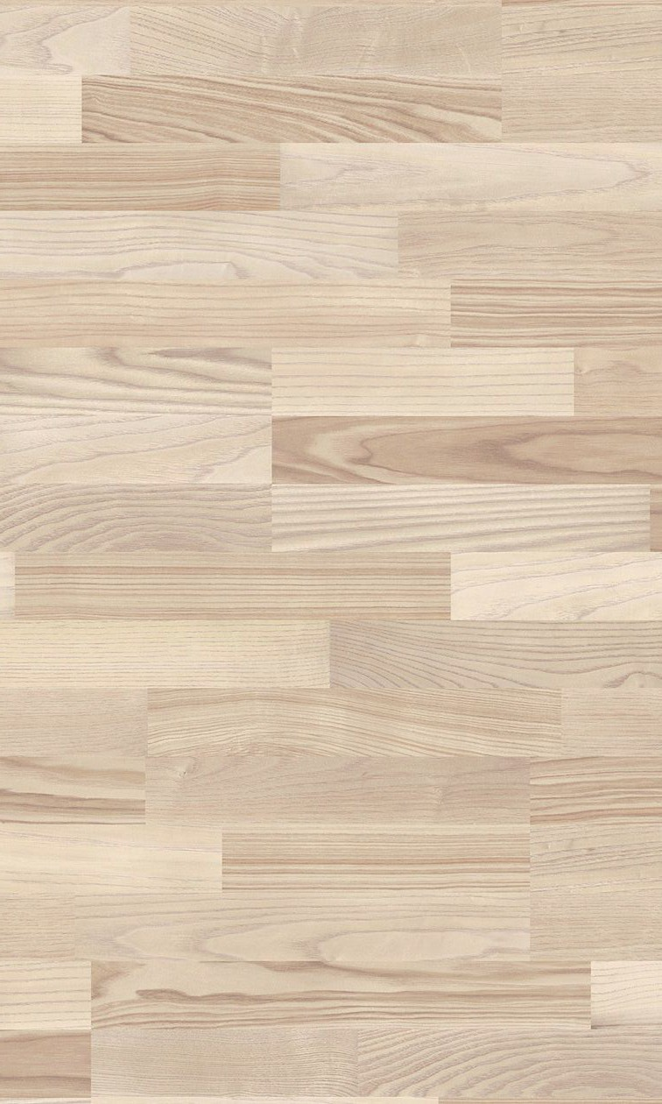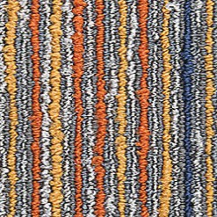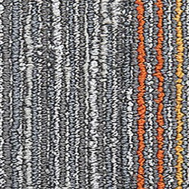Wood wall treatments provide a natural element in the space without requiring natural light. An acoustical wall panel system in the concentration area provides sound dampening along with visual texture. In the collaboration space, a wood wall treatment is used with the text “Keep Going” to create energy in the space.

ITEMIZED EXPENSES

FROM HERMAN MILLER CUSTOM CATALOG

ITEM (INCLUDE LINK AND UNIT PRICE) QUANTITY COST
Glass White Board (48”x72”, Magnetic) $3,500 | 1 | $3,500
Eames Table (Oval, 28 ½” H, Veneer Top) $2,646 | 1 | $2,646
Tu Storage Locker (42” H) $2,921 | 1 | $2,921
Tu Storage Credenza Open $1,350 | 1 | $1,350
Tu Storage Cushion Top (Grade 1) $265 | 1 | $265
Polly Chair (4 Legs) $395 | 6 | $2,370
Polly Chair (Bar Stool) $590 | 2 | $1,180
Layout Studio Engage Leg (Desk End, Double) $373 | 1 | $373
Layout Studio Meeting End (Rectangular, Veneer Top) $164 | 1 | $164
Plex Club Chair (Fully Uph, Grade 1) $1,877 | 2 | $3,754
Plex Left Arm Chair (Fully Uph, Grade 1) $1,677 | 1 | $1,677
Plex Right Arm Chair (Fully Uph, Grade 1) $1,677 | 1 | $1,677
Plex Armless Chair (Fully Uph, Grade 1) $1,592 | 1 | $1,592
Plex Ottoman (Fully Uph, Grade 1) $1,677 | 1 | $1,677
Plex Gangling Bracket $56 | 4 | $224
Plex Power Unit (2K 3012) $328 | 1 | $328
Plex Power Unit (K03) $140 | 2 | $280
Plex Work Table (Adjustable, Laminate) $554 | 3 | $1,662

Public Office Social Chair (Fully Uph, Grade 1) $1,857 | 2 | $3,714
Public Office Focus Café Table (Power, Laminate) $1,191 | 2 | $3,382
Public Office Screen (29”W X 54”H, Grade 1) $829 | 9 | $7,461
Total (Maximum $80,000) | - | $42,197

ADDITIONAL ELEMENTS

ITEM QUANTITY COST
LG 60” LED Television $549.99 | 1 | $549.99
Drift LED Linear Chandelier $335.20 | 3 | $1005.60
Wooden Pendant Lights (White) $89.18 | 2 | $178.36
LED Table Lamp $69.99 | 2 | $139.98
Keurig K-Elite Coffee Maker (Brushed Slate) $129.99 | 1 | $129.99
Microwave $59.88 | 1 | $59.88
Slim Floating Wall Shelf $39.99 | 1 | $39.99
Faux Fiddle Leaf Plant $159 | 1 | $159
White Ceramic Planter (Medium) $119 | 1 | $119
Total (Maximum $5,000) | - | $2,381.79

