^{PROPOSAL}
Big Ten Student Design Challenge
Northwestern University | Baya Weavers
Danqing Gao, Vivien Ng, Victoria Wu

VISION
When our team asked students what they thought was missing from libraries and collaborative workspaces at Northwestern, they wished for “group study spaces that don’t feel oppressive” and “warm-lit settings.” They also complained of “bright lighting and sterile furniture” as the status quo on campus. One theme resonated across their answers: the desire for warmth. Using their feedback, we set out to transform the selected space, a sectioned-off area in the corner of our Main Library, into a learning space that exudes warmth and life. Our design blends cozy colors and elements of nature with furniture arrangements optimized for productivity and accessibility. We call it The Nest.
The chosen location is a glass-partitioned area in an open floor of 1S, the collaborative learning space in Main. From student surveys and observations of how the tables in 1S were being used by individuals and groups, we concluded that the space should facilitate both individual student work and collaborative work such as group studying or project brainstorming. Thus, we designed The Nest to accommodate 15 students in total, with three seats for independent work lining one wall facing outdoors, three groups seating two people, and one group seating four people. Our design includes accommodations such as whiteboards to afford ideating, bulletin boards for interactive displays, and student artwork to promote creativity.
Northwestern chose this space for the challenge because of its high-profile location and open access to the community. When designing The Nest, we sought to make a space that makes every student feel invited and fulfills a variety of common needs. The Nest emphasizes harmony - our design choices are intended to make students feel connected to their environment, to the university community, to their peers, and to their work.
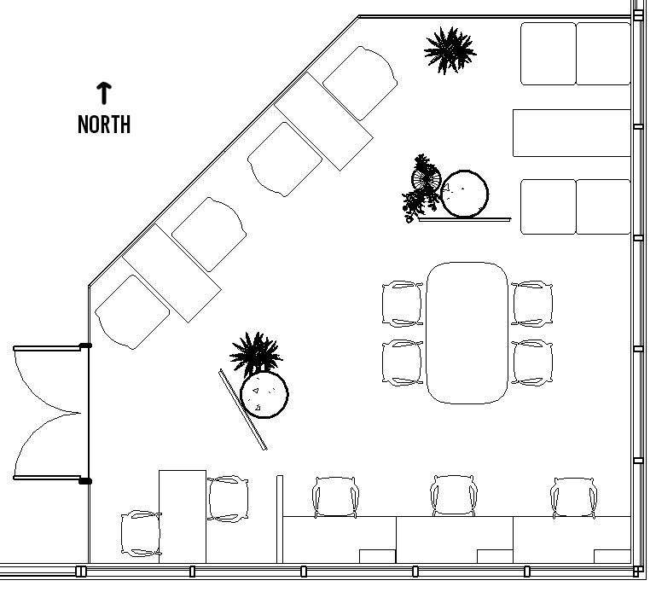

DESCRIPTION
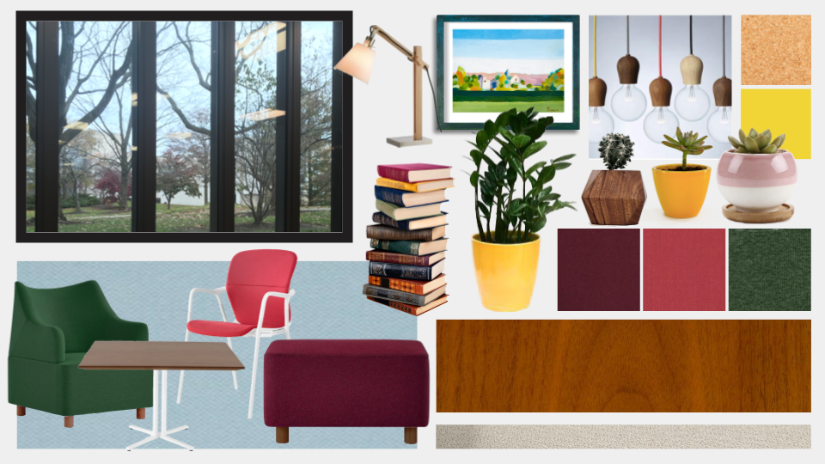
In the mood board above, we show our choices of color for furniture and accent pieces, lighting fixtures, table wood, carpet, and examples of plants and artwork. The Nest is walled on two sides by windows that ascend to the ceiling, giving students a 180-degree view of campus; the pictured window is a November view. Our design’s use of natural colors, live plants, and warm lighting brings the outside in, creating an atmosphere that nurtures discussion and ideas. We chose colors that mirror the exterior view from The Nest - wood finishes and warm earth tone colors with splashes of bold forest green and bright autumnal colors.

Furniture
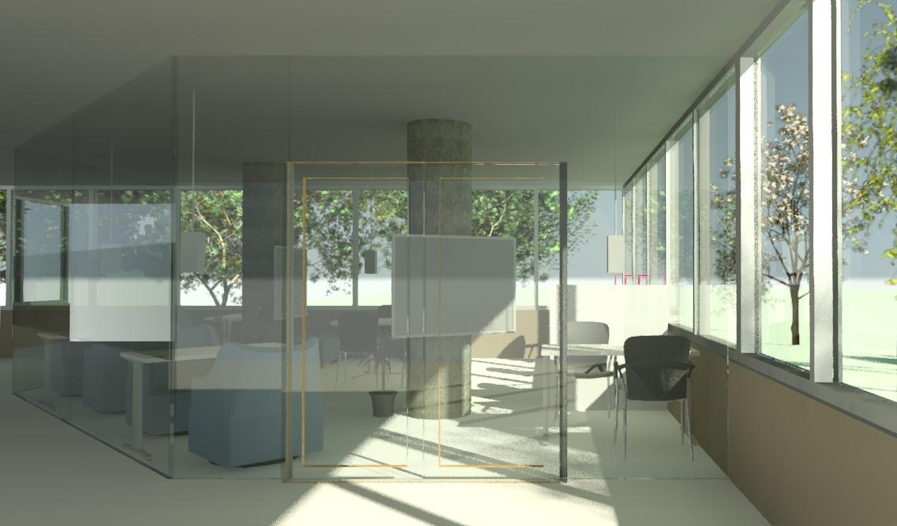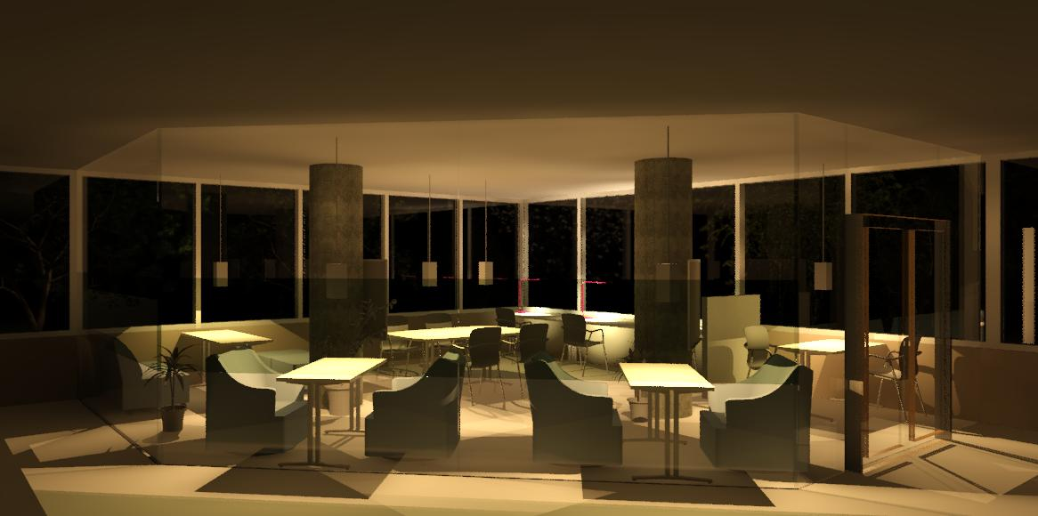
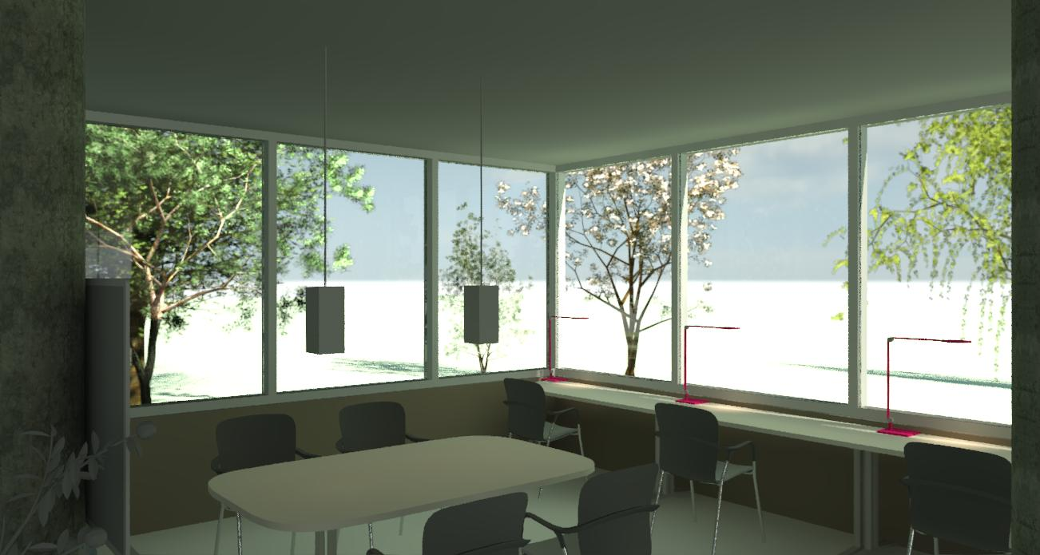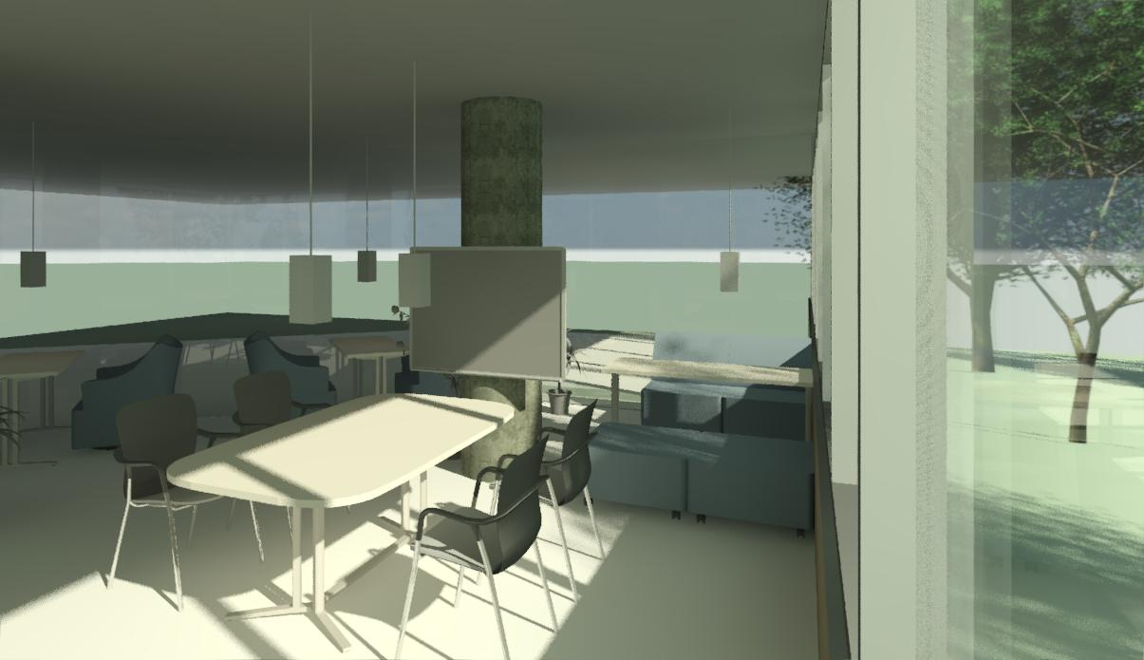

Methodology: We chose furniture for The Nest from the Herman Miller Custom Catalog based on comfort and purpose. Our team visited the Herman Miller Showroom and sat in the Custom Catalog chairs, and determined that they Keyn chairs and Plex chairs were the most comfortable, flexible, and can be put on casters. We also chose Everywhere tables for their flexibility; added wheels and outlets maximize utility. Light brown walnut wood and studio white finishes make the space feel bright and warm. In our arrangement and size choices, we ensured students had enough space to walk and work, and preserved the window view.
Individual workspaces (south wall): Three Everywhere tables line the south wall of The Nest, facing the window so that students can look out as they work. At each table is a Keyn chair on casters, chosen because they can move and swivel easily.
Pair workspaces (south wall): An Everywhere table with two Keyn chairs are separated from the individual workspaces by a Pari screen in a subtle gray color that matches the carpet. Equipped with a convenient whiteboard on the nearby pillar, we envision students using this area dynamically for brainstorming.
Pair workspaces (northwest wall): Two Everywhere tables with two Plex armchairs at each table, all on casters to allow students to join tables to form a group of 4 if desired.
Pair workspaces (northeast corner): Two Plex chairs join to make a booth at an Everywhere table. Two ottomans separate this corner from the conference area, allowing another person to join the table or to set backpacks.
Group of four (center): A large Everywhere table with four Keyn chairs and whiteboard conveniently on the pillar. We imagine students meeting for group projects here.

Other items, flooring, and wall treatment
Standing potted plants (fiddle-leaf fig and philodendron) create subtle divisions between groups, and small succulents in colorful planters line the windowsills. Two whiteboards are provided in strategic locations. Wooden naked bulb lamps above group workspaces and adjustable wooden desk lamps at individual workspaces provide subtle warm light.
Like the work produced in 1S, we want the space itself to be created in a collective effort by students. A unique feature of 1S is its wide structural concrete pillars in the middle of the space. To integrate these industrial fixtures into our vision of warmth, we wrap them in cork board sheets, so that the pillars are transformed into bulletin boards. With provided tacks and notecards, these boards can be used for dynamic student-participation activities, such as asking students to “Recommend a book.” We also designated $800 to purchase student artwork to fill the space. Artwork will be mounted on the glass partition walls to limit visibility from the outside, lending the space a homey atmosphere that encourages creativity.
We chose carpet in a solid light light beige to brighten the space and complement the furniture, in a wear- and fade-resistant nylon. We also extended the glass partition panels to ceiling height, as students requested in surveys, and moved the door to the west wall.

ITEMIZED EXPENSES
FROM HERMAN MILLER CUSTOM CATALOG
ITEM (INCLUDE LINK AND UNIT PRICE) | QUANTITY | COST
[Plex Left Arm Chair $1820, PX101 S A1 FR OU, Twist Forest 8R33] | [1] | [$1820]
[Plex Armless Chair $1613, PX103 S A1 FR OU, Twist Forest 8R33] | [1] | [$1613]
[Plex Club Chair $2485, PX100 S A2 *, Tonus 610 TZN37] | [2] | [$4970]
[Plex Club Chair $2485, PX100 S A2 *, Twist Forest 8R33] | [2] | [$3406]
[Plex Ottoman $989, PX100 S A2 FR, Twist Forest 8R33] | [2] | [$1978]
[Keyn Chair $959, KNN4F P 49 98, Steelcut Trio 533, V2527] | [9] | [$8631]
[Screens, Freestanding $1738+52 (connection),FD300 46.15R, Chain Pearl, 2V01] | [1] | [$1790]
[Everywhere Table Rectangle $1799, DT1AT. 24 60 WT 2U 98 20 NTG] for tables along the south windows | [3] | [$5397]
[Everywhere Table Rectangle $1628, DT1AT. 24 48 WT 2U 98 20 254 (with grommets)] for 2-people booths along the glass panel | [3] | [$4884]
[Everywhere Table Rectangle $1799, DT1AT. 24 60 WT 2U 98 57 NGT] for booth at the corner next to glass panel and east windows | [1] | [$1799]
[Everywhere Table Soft Rectangle $2932, DT1FT. 42 72 WP 2U 98 20 NTG] for the conference table in the center | [1] | [$2932]
[Logic G1000 Grommet Mounted Electrical Distributor $831, Y1425 DA 06] | [3] | [$2493]
Total (Maximum $80,000) | - | [$42672]

ADDITIONAL ELEMENTS
ITEM | QUANTITY | COST
[Carpet $2.65 per sq ft]** | [475 sq ft] | [$1258.75]
[Plants from local flower shop $varies] | [several] | [$500]
[Ceramic Planters $18.00] | [15] | [$270]
[Yellow Planters $118] | [2] | [$236]
[Wood Planters $35] | [1] | [$35]
[Hanging Lamps $99] | [6] | [$594]
[Table Lamps $51.39] | [3] | [$159.57]
[White Board $27.98] | [2] | [$55.96]
[Cork Board 100 sq ft Roll $89.99] | [1] | [$89.99]
[Student artwork] |  | [$800]
Total (Maximum $5,000) | - | [$3740.52]
** Included as part of the $15,000 for floor and wall treatments. Was not included in the total for the above table.

