^{Proposal}
Big Ten Student Design Challenge
University of Minnesota | A.L.N.
Abby Hartman, Leif Kutschera, Nina Newland

Vision

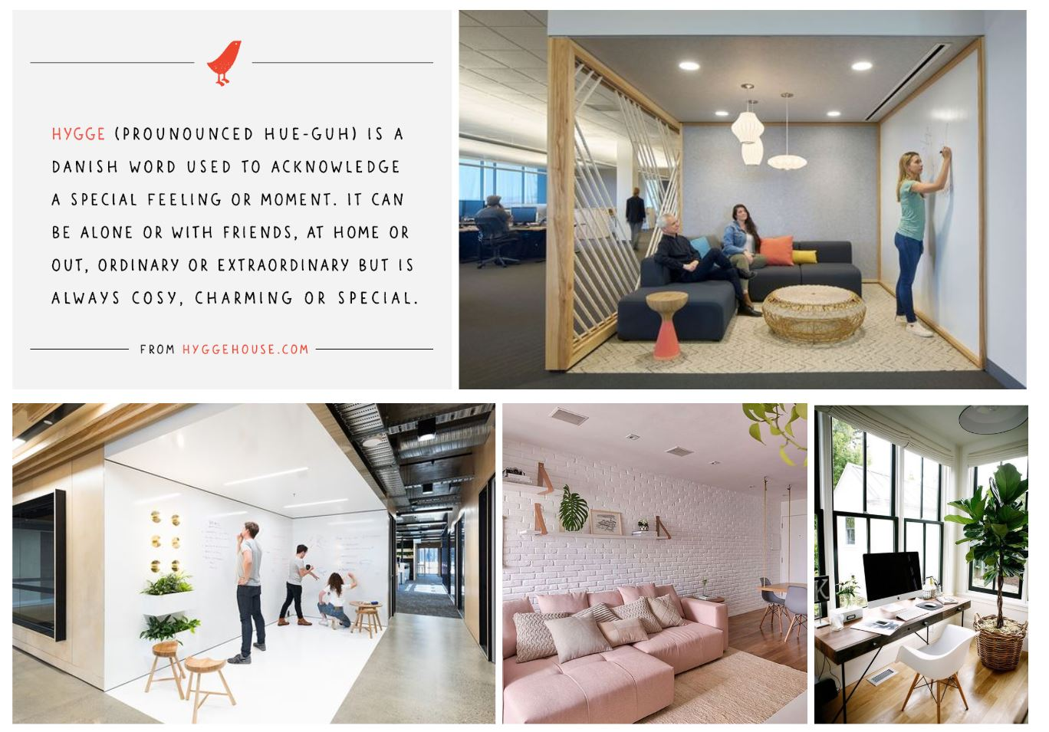

The room to be redesigned is housed in Coffman Memorial Union - a building which is open to a wide range of users from UofM students and faculty, to prospective students and families who receive tours and orientation there. Because the room is in the basement of Coffman, there is no natural light; as such, the redesign of the space will be sensitive to the need for color and quality indoor light. It will be inviting to all users, but catered especially to students who are using the adjacent computer lab. Utilizing the Scandinavian concept of “hygge” - roughly translated into English as “a lifestyle of enjoying company in a casual and comfortable manner” - will make this a destination and selling point of Coffman.

The adjacent computer lab includes primarily individual workstations without room for partner or small group work. Given this, the redesign of the space will be intended for small groups needing a creative escape. To facilitate creativity, ample vertical surfaces will be available for drawing, mapping, and documenting ideas. Additionally, seating options will include areas for partner work in booth style seating and small group work for up to 8 individuals at a “family style” table. Versatility in the seating and the presence of creative walls promote fluidity in the ideation process. These collaborative aspects of the space display core values of the University of Minnesota which translate over to all users of Coffman. In considering the values of the U, sustainability is a primary component of the redesign and will be incorporated into the branding.

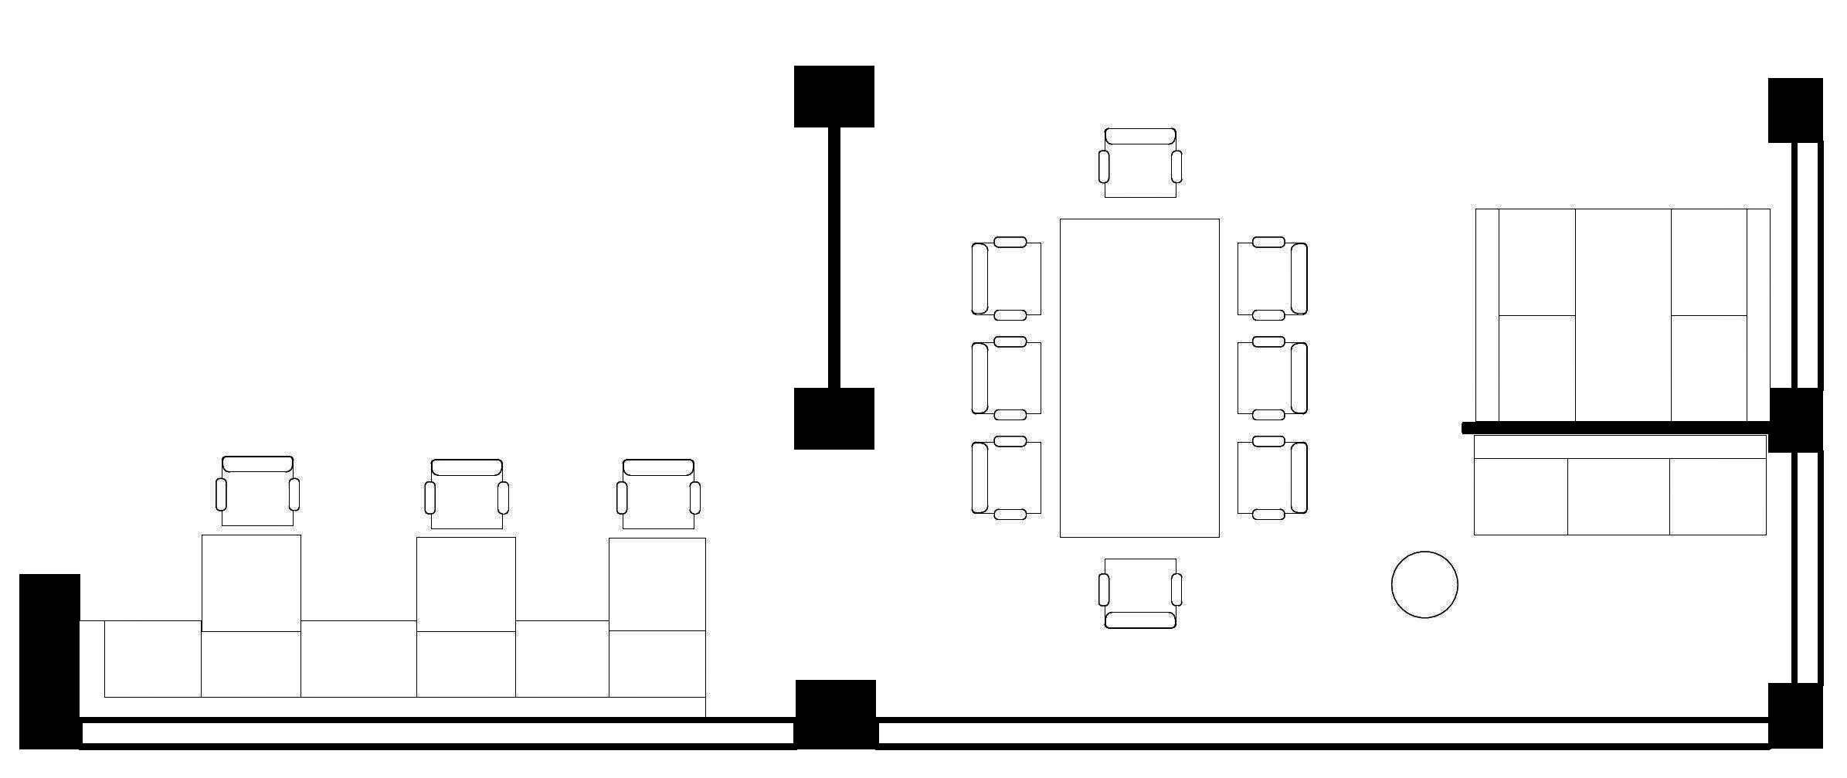

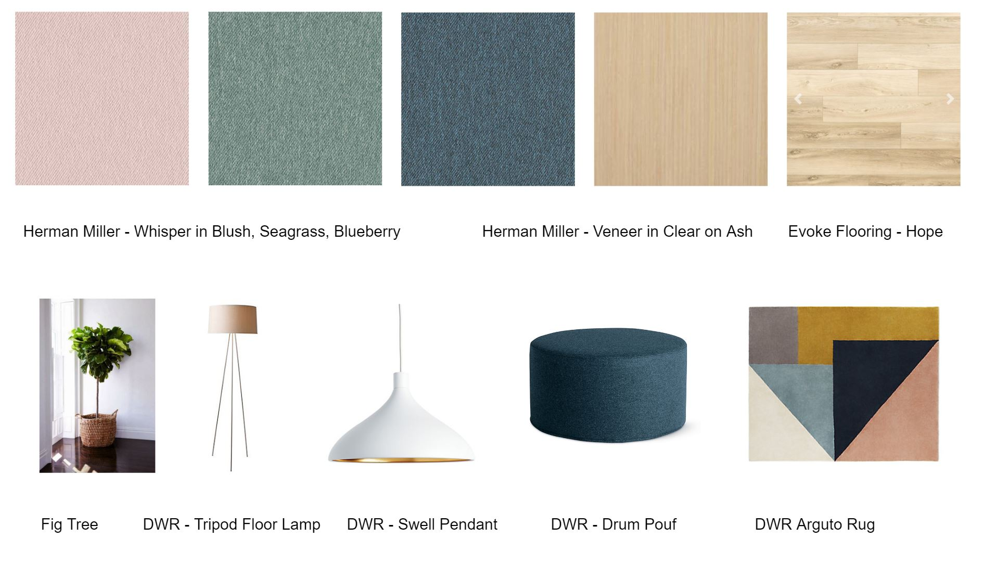

Description

With the concept of Hygge, we wanted to bring in quality light, comfort, and simplicity into an otherwise dull basement computer lab space. The space is intended to provide students with an outlet for creative partner and group work. To make the space versatile for the modern student, the layout offers four distinct zones as follows:
- cafe style benching with tables for partner work
- a large family style table for groups needing ample horizontal surface area
- booth seating with a whiteboard for group work needing horizontal surface as well as vertical surface area
- a lounge nook with a sofa and large whiteboards for fluid creative work
These spaces work together to create a dynamic environment for the users to choose which zone will best suit their needs.
The furniture pieces we selected are fairly simplistic in form, relating to typical scandinavian design. The simpler design also allows the space to blend nicely with the existing computer lab. Each piece relates to the zones that we created, smaller tables for the booths and cafe areas, a larger powered table for the family style zone, comfortable sofa seating for the lounge nook, booths, and cafe area again, and individual task chairs for the family style zone and cafe area. Each piece serves a purpose and gives students a variety of options.
The materials were selected with the purpose of bringing comfort into the space. The furniture ties together with common white frames and shells. Then light wood finishes (Herman Miller Veneer & Wood in Clear on Ash) for the table tops, and delicate pastel upholstery (Herman Miller Whisper in Blush, Seagrass, and Blueberry) for the seating, come together to create a lively oasis with a Scandinavian Flare. We decided to update the current carpet flooring to a Luxury Vinyl for durability, and to bring in a natural wood look. We chose the Evoke Vinyl Composite Core in Hope, again to bring in more light and comfort, without compromising durability. We plan on updating to walls with a fresh coat of paint, then hiring University of Minnesota Art Students to make a custom branding wall on the back wall. This would draw people into the space, and add in school spirit!
Tying it all together, we added decor throughout the space such as a large area rug for the family style zone to add comfort and color, and warm lighting to combat the existing sterile basement lighting. We included a floor lamp in the lounge nook for warmer lighting and pendant lighting over the cafe tables and family style table. And finally, air-purifying plants - such as the spider plant, and fig tree bring in natural elements.

Itemized Expenses
from Herman Miller Custom Catalog
Item (include link and unit price) | Quantity | Cost
[Pari Screen (72”) FT1154672UM $1010] | [1] | [$1010]
[Pari Screen (108”) FT1154696UM $1414] | [1] | [$1414]
[Swoop Left Arm OA101FR $1718] | [2] | [$3436]
[Swoop No Arm OA103FR $1646] | [11] | [$18106]
[Swoop Ganging OA401 $42] | [9] | [$378]
[Layout Table Top GNTPA4896FW $1127] | [1] | [$1127]
[Layout Table Legs GNLSEN48 $510] | [2] | [$1020]
[Layout Table Junction Block GN1358213B $67] | [2] | [$134]
[Layout Table Beams GNBR9691 $235] | [1[ | [$235]
[Layout Table Receptacle GN1355154 $20] | [2] | [$40]
[Layout Table Junction Jumper GN135348A $97] | [1] | [$97]
[Layout Table Power Entry GN135118C $244] | [1] | [$244]
[Glass White Board (48”x48”) Y7232S4848N $2139] | [1] | [$2139]
[Glass White Board (48”x72”) Y7232S4872N $3255] | [1] | [$3255]
[Glass White Board (24”x36”) Y7232S2436N $721] | [2] | [$1442]
[Keyn Chair (Seat Pad Only) KNN1SC9 $855] | [11] | [$9405]
[Everywhere Table (Rectangular) DT1AS3060WT $1569] | [1] | [$1569]
[Everywhere Table (Square) DT1B3030WS $1018] | [3] | [$3054]
Total (Maximum $80,000) | - | [$48173]
Additional elements
Item | Quantity | Cost
[Design Within Reach Drum Pouf Wide (With Tray) $375] | [1] | [$375]
[Design Within Reach Arguto Rug (8’x10’) $1995] | [1] | [$1995]
[Design Within Reach Swell Medium LED Pendant $249] | [4] | [$996]
[Design Within Reach Tripod Floor Lamp $395] | [1] | [$395]
[5’ Fiddle Leaf Fig Tree $200] | [1] | [$200]
[6” Spider Plants $15] | [4] | [$60]
[Custom Branding Wall Art by UMN Art Students $150] | [1] | [$150]
Total (Maximum $5,000) | - | [$4171]

